

INTERPRETING YOUR RACEPAK DATA

A QUICK COURSE ABOUT UNDERSTANDING WHAT ALL THOSE GRAPH LINES ARE TELLING YOU.

There has been a lot written about installing the hardware components of your data acquisition system, and even more about the software it uses. Each Racepak data acquisition system comes with two large hardcover manuals that cover these topics in great detail. However, even after reading these manuals, some racers are still like a deer in the headlights when they download their first recording. Once presented with a screen full of graph lines and numbers they are left wondering what each of these pieces of data mean to them. The purpose of this manual is to provide you with a jump-start toward understanding all of those lines and numbers and how you can make the best use of the information they provide.

Since the manuals that came with your data recorder explain the process of how to take a recording, and how to upload and display it on your computer screen, we will start with the assumption that you have mastered that portion of the process. The items we will discuss here will all be addressed as if you have a recording displayed on your computer screen. Since Racepak systems are most widely used in drag race applications we will also discuss the topics in that context, although those who are using their recorder in other types of applications will find this information just as useful.

One word of caution, this manual is not intended to be an absolute tuning guide, or one that proides the answers to all possible situations. It is merely for the purpose of helping you get started with monitoring various functions of your car and recognizing what your graphs will look like during some common occurrences. Since similar occurrences can look somewhat different on vehicles of different categories, it would be impossible to show you examples of all possible situations. So keep in mind that what you will see here are examples, and not absolute guidelines. Through experience you will ultimately develop your own eye toward identifying different occurrences as they appear on your graphs, plus guidelines of what is acceptable, and what isn’t, with your own car.

SETTING THE ZERO POINT

It is important that one of the first things you do when downloading a run is to establish a ‘Zero Point’. The zero point is the exact point in the recording that you have identified as the start of the run. Since the recorder started collecting data well before the car left the starting line, and continued recording long past the finish, your actual run is somewhere in the middle of the total time you were recording. By locating and marking the actual starting point of the run you will accomplish two things; you will be able to move the vertical screen cursor to any point in the run and know exactly how far into the run (time wise) the event occurred, plus whenever you recall the run file the screen will display the run starting at a half second before the zero point and out to approximately two seconds beyond the normal length of time for one of your runs. For example, if your car typically runs mid-eight second elapsed times, we have probably defaulted the screen to display everything from –0.5 second before the zero point, until 10.0 seconds after the zero point. This doesn’t mean that you are deprived of seeing anything that was recorded before or after that, you will just have to use the arrow icons on the tool bar to scroll to the left or right of the screen view to bring those items into view.

Where you set the zero point of your run is a matter of personal preference, and is often dictated by the type of car you have. Some people will want to use a zero point that is representative of the exact moment when the driver initiates the run, while others prefer trying to identify the point where the car tripped the electronic beams and started the clocks. These two points aren’t one in the same as you might expect they would be, especially on cars that launch from an idle using a centrifugal clutch. For those cars, using a reference such as the fuel pump pressure (most have mechanical fuel injection where the pressure initially drops when the throttle is slammed open) allows them to measure the time between when the driver starts the run and the first movement of the rear tire. Knowing this time differential is helpful in clutch tuning. Cars that launch with the engine RPM up, or those that launch against a transbrake, will more often than not use the first movement of the drive shaft, or the transbrake event, or the clutch two step event, as their zero point reference. Whichever event you use to establish your zero point it is important to be consistent in locating this reference point on every run you save. It will generally be the alignment point when comparing one run against another, such as when you overlay runs. So get in the habit of establishing the zero point of your run as soon as you display a new recording on the screen. How to set the zero point is covered in your Quick Start manual.

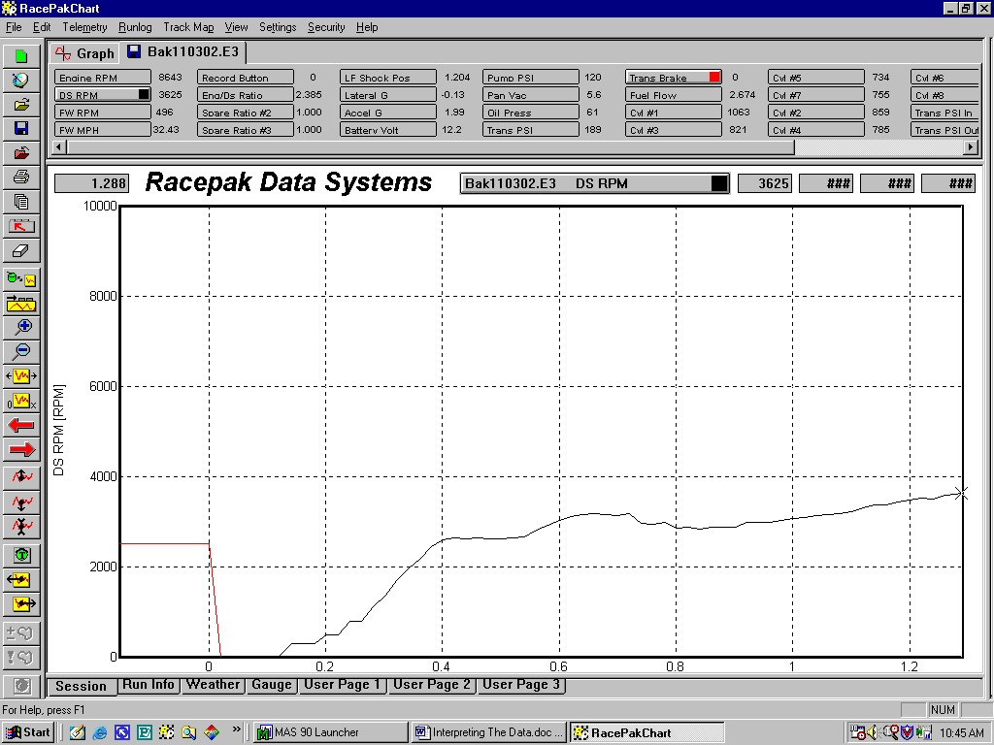
Notice in this example that we have zoomed in on the transbrake event (red graph line) and that the zero point on the time line has been set to coincide with the exact moment that the transbrake was released. It could have been aligned with the first movement of the drive shaft (black graph line), or any other function you choose, but when done as shown here, you can then place the screen cursor on the start of the drive shaft graph and the time window at the upper left hand corner of the graph will indicate how much time elapsed between the release of the transbrake and when the drive shaft moved. That would indicate how long it took the car to react to the driver’s command to go. This is not to be confused with the reaction time that is shown on your ET slips. Another point to remember here, should you be trying to coordinate your graph with your time slip, is that the onboard recorder does not make any allowances for rollout, as does the track’s timing equipment. The data recorder monitors the actual movements of the car, so there will always be a slight difference between your time slip and the graphs.

ENGINE RPM

Almost without fail everyone wants to see their engine RPM graph before looking at anything else. Racers seem to be able to instantly relive and evaluate their run just by looking at this graph, so it is usually the first graph that is illuminated on the screen.

There is much to be learned by studying the engine RPM graph. You can see the RPM at idle and the RPM at which the car was launched. It will display the RPM at which the transmission was shifted and at what intervals into the run the shifts occurred. You can see if the engine achieved the RPM is should have in each gear, and whether the engine was short shifted or over revved. You will know if the engine lacked power and was pulled down below its power range when shifted into a new gear. You can also see if the engine was missing while it was under load. There is also living proof of whether the driver shut the engine off early as he claimed, or whether he actually drove it well out the back door. The recorder monitors everything in great detail, and remembers it with unerring accuracy. It will show you exactly what happened whether you like it or not.

Now that you have the ability to plot your engine RPM it will provide you with a tool that has far reaching benefits. Your engine builder will be one of the first who will enjoy seeing this information. With it he will be able to compare the graphs with the data he recorded when he had your engine on his dyno. This will give him the ability to make a call on whether the engine is being operated in the intended RPM range. He’ll be able to give you educated advice you about such things as gearing, cam profiles, and other related ingredients of the performance equation.

Knowing how the engine RPM is plotted will also help you understand how your recorder works in general. Remember the old ‘connect the dots’ pictures you drew as a child? The graph on your computer screen works in much the same way. Every sample that is recorded is plotted on a two-axis graph. The vertical axis is the scale value, and the horizontal axis is the time line. As each sample is placed on the graph the software connects each subsequent ‘dot’ with a line. This is the graph line you see when you illuminate the Engine RPM channel button. The graphs for all channels of data are generated in the same manner.

Another valuable piece of information you will want to remember about engine RPM is that the graph line represents a ‘calculated value’. In other words, the recorder monitors the time between each sample and then the software calculates how many revolutions the crankshaft would have made over a period of sixty seconds if this rate were maintained. This is how we arrive at RPM (revolutions per minute). This knowledge is helpful in understanding why you sometimes see ‘spikes’ in the graph. If the recorder receives an extra voltage signal between those it would normally sense, the software will interpret this as the crankshaft rotating faster and calculates this as being a higher RPM value (more pulses over a sixty second period). Conversely, if an ignition pulse is missed, the recorder thinks the engine RPM has slowed or stopped, and the RPM graph will head toward zero RPM, only to return to the true RPM as soon as two more properly timed pulses are recorded again. Since these phenomenons occur within a fraction of a second the change in the RPM value, and then back to normal again, is so quick that the graph line appears to have a spike in it. These ‘spikes’ are not a recorder glitch. As we said before, the recorder monitors everything in great detail, but isn’t that why you purchased your data recorder. Now that you understand why those so-called ‘spikes’ occur let us also tell you that almost without fail, spikes in the graph lines are the result of defective or improper spark plug wires.

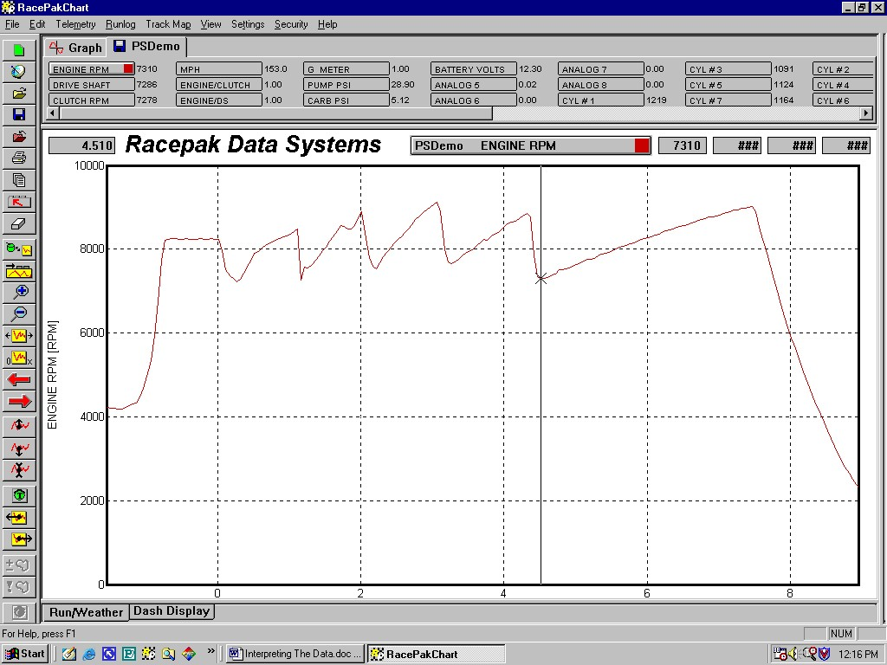
This screen view showing just the engine RPM of a five-speed car illustrates how many things can be determined from a single graph. Here we can see the launch RPM, the RPM and time at which each shift was made, the RPM the engine was pulled down to on each gear change, how long the engine was in each gear, and the exact point where the run was terminated. If this were your car you would probably be interested in the little bobble in RPM just before being shifted out of second gear. The black vertical cursor can be placed anywhere on the screen, allowing you to determine such things as how low the engine RPM fell on the shift into 5th gear (which was 7310 in this example, as verified by the number alongside the Engine RPM channel button).

DRIVE SHAFT RPM

Everyone wants to know if their tires are spinning. Since racing is a game of traction, knowing whether your tires are biting or slipping is a key element to how quickly you can accelerate your car. We monitor this by graphing the speed at which the tires are turning. Attaching a sensor to the wheel itself to monitor tire speed is difficult, but since there is a direct link between the drive shaft yoke and the wheel, mounting a sensor on the rear end housing and monitoring the revolutions of the drive shaft yoke can provide the same information. This is why the term Drive Shaft RPM is used when we are actually using this channel to monitor the tire RPM.

Once again this RPM is plotted on a time line. If the rear wheels were not turning, or they were rotating at a constant RPM, the graph line would be horizontal (but at different heights on the RPM scale). As the drive shaft RPM begins to increase the graph line will turn upward. The more rapid the rate of change of acceleration, the more vertical the graph line will become. Generally, at the start of a run the line is nearly vertical, after which it will become progressively more horizontal further into the run as the rate of acceleration decreases. Tire slip is indicated by the graph line being more vertical at a given point in the run where it should not be that steep, or by a sudden change upward anywhere in the run in the rate of the drive shaft RPM. One thing to look out for that can throw you a curve is bumps in the track. If the car hit a bump that compresses the rear tires, the effective radius of the tire is reduced. Even though the car is still traveling at the same rate of speed, the driveshaft RPM will increase making the graph look like the tires have momentarily lost traction. A quick way to verify whether this is a bump in the track, or true tire spin, is to look at the acceleration G-force at the same point in the run. If the acceleration G-force does not decrease as the drive shaft RPM increases, it is unlikely that the tires have lost traction. A bump in the track is also characterized when the graph line makes a quick return to its normal shape (just a sharp hump in the graph), whereas with true tire slip the graph line is not as likely to recover quite as fast.

It will take a number of runs for you to create yourself a database of what your drive shaft RPM graph should look like, but eventually everyone develops a graph curve that they try to achieve. This is usually based off of the drive shaft graph from your quickest run to date. By using your quickest run as a reference, and overlaying the driveshaft graph from your most recent run, you can visually see where the tires are accelerating faster or slower, and where the tire speed is higher or lower at any point on the track. Overlaying drive shaft graphs from multiple runs in the same lane at the same track will also provide you with graphic evidence of where the bumps in that lane are located, and whether those bumps are causing your car to lose traction.

Regardless of whether your car is a multi geared car, or a direct drive car that uses clutch management to apply the power, it is helpful to align your screen cursor with each gear change or clutch stage and look at the drive shaft graph at each of those points in the run. Observing whether the tires are maintaining traction or slipping as additional power is applied to them is valuable information. One piece of advice though, although we tend to think that spinning the tires is detrimental to elapsed time, not all tire slip is bad. In some cases a small amount of tire spin is actually beneficial. Sometimes when a car is shifted into the next gear the gearing can pull the engine down below the RPM where it makes its best power, and the car is slow to recover back into the prime part of the power band. By slipping the tires slightly the load on the engine is reduced, and the engine is free to jump back up to the RPM where it makes better power, thus aiding the overall run.

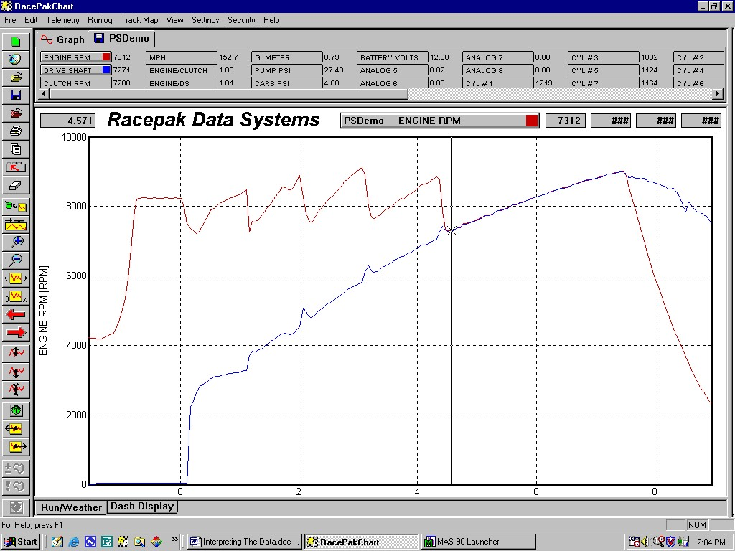
When the drive shaft RPM is displayed on the screen with the engine RPM you can see the correlation between the two. Notice in this example how the rate of drive shaft acceleration is very steep at the start of the run, and then tapers off as the car progresses down the track. You can also see how the drive shaft RPM briefly jumped up on the gear changes, indicating that the car spun the tires as each gear was engaged. Closer inspection will reveal that the drive shaft RPM did not recover much after the initial spin when shifted into 2nd gear, meaning that the tires were most likely spinning throughout most of the time the car was in 2nd gear.

CLUTCH RPM

On cars with a manual transmission it is common to monitor the clutch RPM. The term Clutch RPM may be somewhat confusing as the RPM we are actually monitoring is that of the transmission input shaft. However, if we consider the input shaft to be a component of the clutch disc(s), then the term is valid. We use this channel of information to help us determine the output RPM of the clutch assembly, so the name has stuck.

You might wonder why we bother looking at Clutch RPM when it is the clutch slip that most racers are really interested in? In some respects Clutch RPM provides the same information as clutch slip ratio (Engine/Clutch channel button), but is viewed in a different manner. When you display both the Clutch RPM and the Engine RPM on the same screen you have a quick visual of where both are operating at the same speed, and where they are not. When the clutch graph line lays directly over the top of the engine RPM line the clutch is locked up.

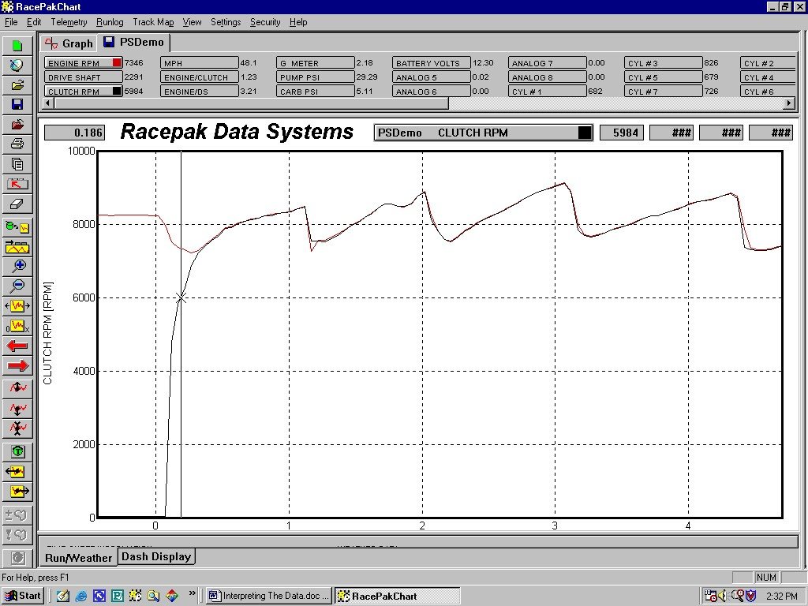
Here the clutch RPM is shown as a black graph line, and the engine RPM is the red line. Notice how the clutch line will lay directly over the top of the engine RPM line when the two are rotating at the same speed (locked up). If you look closely you can also see where the clutch is slipping, such as just after the 1-2 shift, and again after the 4-5 shift. The next graph (Engine/Clutch) will provide you with an easier to read view of clutch slip.

CLUTCH SLIP

Clutch tuning is one of the more critical aspects of racecar tuning. A car that uses a clutch, as opposed to an automatic transmission with a torque converter, is very dependant upon the set up of the clutch to apply just the right amount of power to the rear wheels to achieve best performance. Too little power and the car will not accelerate as quickly as it might have. Too much and the car also slows with tire spin. The trick is in determining just how much power you can apply, and also in evaluating whether the adjustments you perform are achieving the results you desire. When dealing with ‘tuning in the bellhousing’, trial-and-error is about as productive as trying to support yourself by playing the lottery. Very few hit the jackpot. You need something more than your eyes, ears, and a time slip to hone in on that Mega-number. The data from Clutch Slip hasn’t made everyone a lotto winner, but it sure had more than paid for itself.

As explained earlier, there is usually the need for a degree of clutch slippage to avoid overpowering the rear tires. To determining how much the clutch is slipping, and where during the run it is slipping, we compare the clutch input RPM (engine/flywheel) to the clutch output RPM (transmission input shaft). In cars that do not have a transmission (i.e. direct drive cars) the engine RPM is compared against the drive shaft RPM, since there are no transmission gear ratios to confuse the equation. In either case the differential of these two RPMs is your clutch slip ratio. When the engine is running, but the clutch is disengaged, the differential or clutch slip is 100%. The clutch slip graph line will be off the top of the graph scale at this time. As the clutch starts to engage, and the input shaft begins to turn, the ratio of slippage will decrease and the graph line will appear at the top of the scale and be heading downward, toward the bottom of the screen. The rate at which it is locking up will be indicated by how vertical or horizontal the graph line is. When the clutch reaches full lock up (or in the slang term, “one to one”), the line will change from mostly vertical to horizontal. If you have the Engine/Clutch scale illuminated on the left side of the graph, the clutch slip line will rest directly on the dotted horizontal ‘1’ line when there is no slippage. By moving the cursor to different positions on the graph you will be able to- read the ratio of slip at that location alongside the Engine/Clutch channel button at the top of the screen. This number is the engine RPM (input) divided by the clutch RPM (output). The span of the Slip Ratio scale is from 1.000 to 6.000. The 6.000 will be displayed when the clutch is disengaged, or the engine speed is six time or greater that of the input shaft RPM. When the engine and clutch are locked up at the same RPM the number alongside the channel button will read 1.000. The software will calculate and display any slip ratio less that 6:1.

How much should your clutch slip, and how soon should it lock up? Wow, if we could answer that from where we are sitting we would be wealthy. The truth is that not only does the answer to that question very from car to car, but also from track-to-track, lane-to-lane, and even under various weather conditions, and that is if all other parameters on the car remain the same. Clutch tuning is what separates the men from the boys, and the winners from the also-rans. It is why those who perform this task rely heavily on their data recorders to provide them with information that can be used in advance of a run to make educated decisions about what changes might be needed to perform better. Building a database of how your car performs with various clutch set ups in different conditions will take quite a few runs to acquire, but once you have that information you will be light years ahead of many of your competitors in knowing how to adjust the clutch to the conditions before the run, rather than after it.

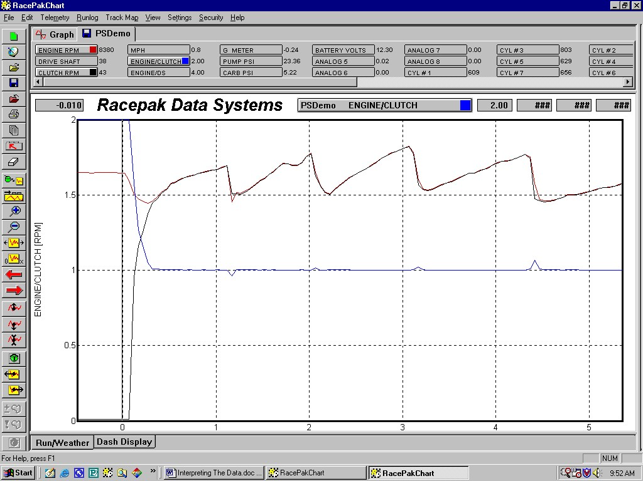
In this screen view we have added the Clutch Slip graph (blue line) to the engine and clutch RPM lines of the previous graph. With this channel you can see the rate at which the clutch was locking up at the start of the run and where it achieved full lock up. When the line becomes horizontal, as shown here where it lies directly upon the dotted horizontal ‘1’ line, the engine RPM and the clutch RPM are at the same RPM. Note the small amounts of slip that are evident on the blue graph line of this Pro Stock car after each gear change. These are a good indicator of how much the clutch slipped, and for how long of a period of time it slipped. The small rises above the dotted graph line on the second, third, and forth gear shifts all show that the engine was turning faster than the input shaft at these points in the run.

On cars without a transmission (direct drive cars) the rate of lock up is much slower than shown here. A Crewchief will often program the clutch to slip over most of the run in order to avoid overpowering the tires.

See how much easier it is to read the clutch slip with this graph as opposed to just looking at the Clutch RPM graph. It becomes even easier yet when you have this view on a large computer screen, plus have the ability to zoom in on any portion of the graph. This graph will allow you to quickly determine when during the run the clutch is slipping, how much it is slipping, and how long it slipped.

CONVERTER SLIPPAGE / CONVERTER EFFICIENCY

The term Engine/Ds Ratio on the channel button might have initially been a little confusing to you, but just like clutch slip, it is a comparison of the input side RPM of a torque converter versus the output side RPM. You will probably call this your Converter Slip or Converter Efficiency graph.

The difference between converter slip and clutch slip in that, with few exceptions, there is no easy way to install a sensor in the bellhousing to monitor the output side of the converter as you can on the transmission input shaft of a clutch car. This means that in most cases you must compare the engine RPM to the drive shaft RPM in a converter car to attain a differential ratio. By doing it in this manner the differential equation will include any slippage that is occurring in the converter, plus that in the transmission, as well as reading the gear ratios. For this reason it is critical that you pay close attention to your differential numbers when everything is new and fresh. These numbers will serve as your baseline in determining when things are starting to lose their efficiency. Many racers of automatic transmission cars also closely monitor the temperature and pressures of their transmission as an indicator of its condition. High fluid temperature or lower pressures can be a warning that something is amiss. If you see the converter differential ratio numbers starting to grow, and the transmission pressure or temperature has changed, it is a good bet that the problem may be the transmission, and not the converter.

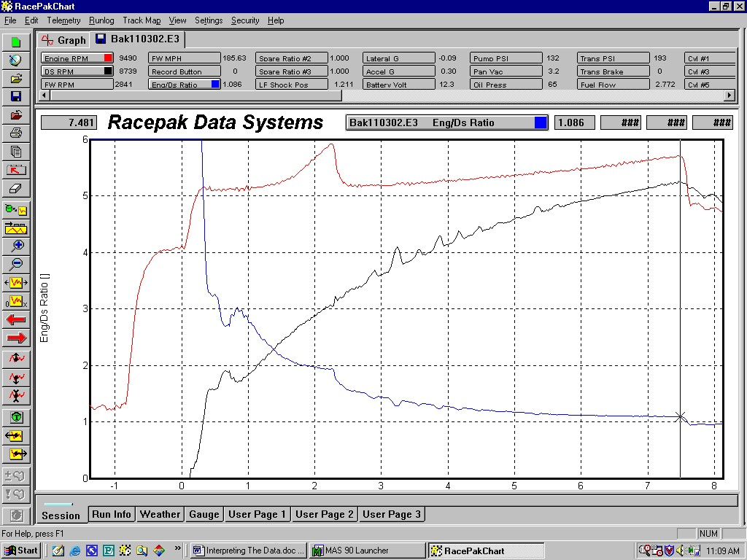
Converter Ratio, as shown with the blue graph line, is similar to clutch slip, yet different. Converter ratio is a measurement of the differential between the engine RPM (red graph line) and the drive shaft RPM (black graph line). A clutch slip graph does not have to contend with transmission slippage or its gear ratios. You can clearly see in this example the rate at which the converter is engaging, and even where it slips at a greater degree again when the resistance between rear tires and engine increases. Note how the slip line was almost horizontal (locked up) in low gear, and then became more vertical when the transmission was shifted into high gear. Between the combined slippage that occurs in the converter and the transmission, automatic transmission cars never achieve complete lock up. A differential ratio of 1.06 to 1.12 is common in high gear at the end of the run.
EXHAUST GAS TEMPERATURES

Exhaust gas temperatures, also known as EGTs, are a hot topic both literally and figuratively. Measuring the temperature of the exhaust gases as they leave the cylinder head is used as an indicator as to how much heat is being produced in the combustion chamber. For years tuners have read the effects of the combustion chamber heat on their spark plugs as a method of determining how hot it was inside the cylinder. They then used this as a gauge as to whether the cylinder was rich (cool) or lean (hot). Unfortunately this method only provided a snapshot of the temperatures during the run. Sharp tuners ultimately discovered that a lot took place, temperature-wise, between the starting line and the finish line. It was possible to be both rich and lean at various times during the course of a run, but the spark plug usually only retained witness of which condition occurred last. Since data recorders allow you to monitor many samples per second of the EGT, this permits you to see what the engine is doing at all RPMs and under all load conditions, over the entire distance of the run

Explaining how to read your EGTs is as much about dispelling some myths as it is about what to look for. First, it should be pointed out that the exhaust gas temperatures are not an indicator of how efficiently you are burning your fuel. That is the job of an Air/Fuel (O²) sensor, which measures the oxygen content of the exhaust gases. EGTs measure the residual heat left over after the combustion process. It should also be noted that there is no magical predictable EGT temperature number at which your engine will perform best. That number will vary from engine to engine depending on a lot of things like the type of fuel you are using, the compression ratio, whether the engine is blown or unblown, camshaft timing, ignition timing, and on, and on, and on. In this regard one of the most dangerous things you can do is to listen to your buddy when he tells you to tune for a specific exhaust gas temperature that works best in his supposedly similar engine. Your particular engine combination may fall hundreds of horsepower short of its potential at his recommended temperature by being too rich, or it might melt the headers off of the engine by being dead lean. While you are searching for the temperature at which your engine runs best (and is safe), continue to consult the other tuning guides you have always used, like reading your spark plugs or checking the bearing and pistons, and for goodness sake always approach your best tune up from the rich side, not the lean side, and in small incremental steps. There are no shortcuts to attaining this information.

Another myth that we sometimes hear is that the exhaust gas temperatures can be misleading. Investigation usually reveals that this comment comes from someone who has misinterpreted or ignored what the data is telling them, such as the racer who says his or her EGTs were cold, yet the engine suffered heat damage. Generally this racer has failed to notice that his temperatures were unusually high before they became cool. Although most racers will never experience this, it is possible to get a cylinder so lean that most of the remaining heat will dissipate before the exhaust valve opens. When the exhaust valve does open, and the EGT thermocouple is exposed to the exhaust gases, the temperature will appear low. In these rare cases it would have been helpful had the racer looked at the temperature before the run, and during the early stages of the run, rather than just at the end of the run. There have even been recorded cases where a cylinder temperature was unusually cold, and was very lean, yet the cylinder did not hurt itself. Be careful in this circumstance. Adding a small amount of fuel will sometimes bring the temperature back into a range where there is just enough fuel that it can hurt itself. But trust us, there will be telltale temperature data on the graphs if these conditions exist. Overall, exhaust gas temperatures are very reliable and a great tuning guide for those who use them properly.

In addition to using the exhaust gas temperatures as a tuning guide they are also a first line of defense in spotting other problems. Ideally you would like to see the EGTs as close to each other as possible from idle RPM right through wide open throttle at the end of the run. Most tuners are happy when they can keep the hottest and the coldest cylinders within 50°F of each other. When you have achieved that you have a happy motor. But also keep an eye on them for any usual occurrences in each cylinder. Look for any that may suddenly become hotter than normal, or that might go cold. This is a red flag that something is taking place that has disrupted the normal air/fuel requirements for that cylinder. It could be a valvetrain problem, ring problem, fuel supply or distribution problem, ignition, or a multitude of other things, but don’t ignore it. Find out what is causing the problem before it gets expensive. Data recorders often end up saving racers more money than they cost, if they’ll just pay attention.

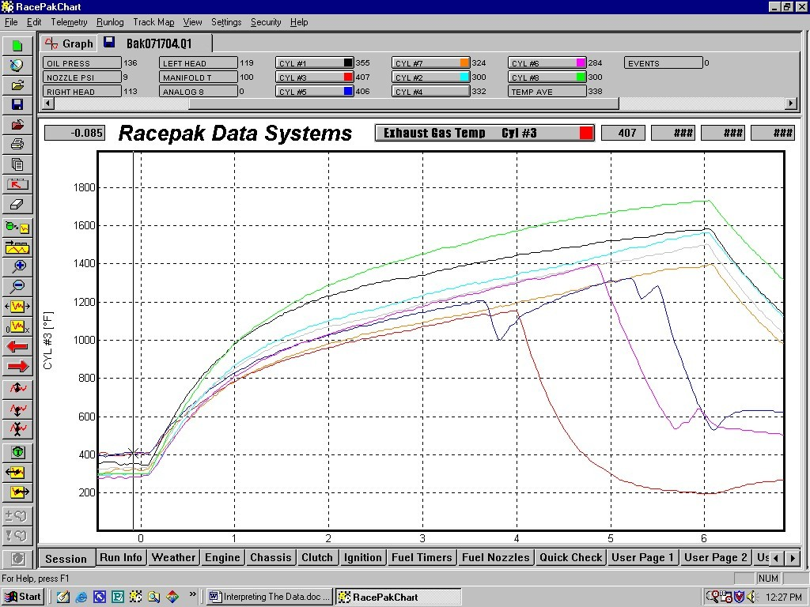
Now here is an ugly picture that does a beautiful job of illustrating the value of monitoring exhaust gas temperatures. This supercharged car has a fairly normal looking set of EGTs at the starting line (at the vertical cursor line), but then during the run it all goes awry. The #8 cylinder (green graph line) is quite a bit hotter than the other cylinders (1727 at the end of the run), while three other cylinders have gotten so rich they have quit firing. With this knowledge (and assuming it is not an ignition system problem) the crew chief can richen up the #8 cylinder to cool it off, and then go to work on the overall fuel volume to keep all of the cylinders lit for the full run. EGT graphs are one of the best places to spot problems.

ACCELERATION G-FORCE

This channel of data might be one of the more valuable, yet most overlooked, pieces of information available to you. If your data recorder is equipped with a longitudinal G-meter it is used for the purpose of recording your acceleration G-forces. The objective of a drag race car is to maintain the highest rate of acceleration G-force over the greatest length of time. This device helps you evaluate just how well you do that. Think of it this way; if you monitored your rate of acceleration on two runs, and then averaged the samples taken for each run, the run with the highest average G-force (not necessarily the highest G-force number) would have the quicker elapsed time.

In the earlier discussion about drive shaft RPM we spoke of how to determine whether a rise in the graph line was a loss of traction, or just a bump in the track. We suggested that you could look at the G-meter and determine which it was. That was done by noting whether the G-force at that moment diminished, as it would with a loss of traction, or remained relatively constant, as it most likely would when driving over a bump. In other words, did the car maintain its rate of acceleration, or did it slow down. Since most everything we do with a racecar is aimed at improving its ability to accelerate, it only makes sense to use this channel of data to verify the results of any changes that are made. For example, if you make a tuning, clutch, or converter change, overlaying the acceleration graph line from the before and after runs will show you exactly where improvements or loses occur.

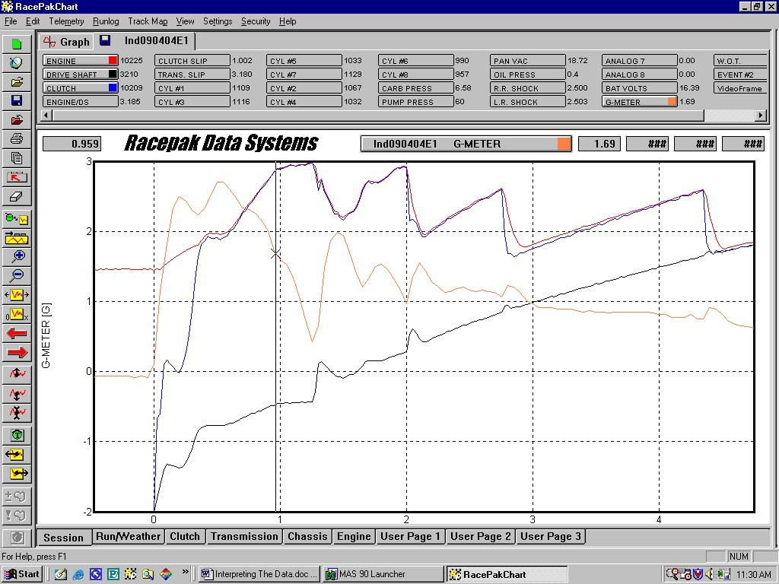
This screen view illustrates how easily the Accel G-meter can be used to spot loses in acceleration. Here the driver ran the engine up on the rev limiter rather hard in low gear (just to the right of the vertical cursor line), and again in 2nd gear. Notice how the G-meter line (orange) takes a large drop, and the drive shaft graph line (black) stops accelerating, when the engine hits the rev limiter. The G-force dropped from 1.67 Gs to 0.46 Gs, then jumped back to 1.98 when the car was shifted. Also note the resulting tire spin that occurred on the 1-2 and 2-3 shifts. You can also see a large degree of clutch slip when the 3-4 and 4-5 gear changes were then short shifted.

LATERAL G-FORCE

I can hear you now, “Why do I need a lateral G-meter. I race in a straight line, not around corners?” That is a typical first response when racers hear that their new data recorder has a lateral G-meter in it, but once they have been shown the value of monitoring the side-to-side G-forces that are present in their car their opinion starts to change. This is especially true in higher horsepower cars.

Drag racers may race on a straight-line track, but often they do not drive in a straight line. Those who compete in break out classes where winners are determined by thousandths of a second need ultimate consistency. When their car slows down they need to know why. Often the answer is in the distance the car traveled, rather than in the tune up. When watching from the starting line or stands, or even the driver’s seat, it isn’t always apparent when a car is driven all over the lane or out of the groove. It takes some data acquisition to recall just what has happened. It does little good to dial in more ET after a slow run, and then drive the car straight to a break out on the next run. Knowing it was how it was driven, in addition to how it was tuned, can avoid that mistake.

Higher horsepower cars also use their Lateral G-force to watch for tire shake. Since tire shake causes the car the waddle on the sidewalls of the tires, this shows up as side-to-side motion on the G-meter. Often the little quivering that precedes full-blown tire shake isn’t noticeable (or wasn’t remembered) by the driver during the heat of battle. A sharp Crewchief will keep an eye on his lateral G-force to see if his next engine or clutch tuning adjustment is flirting with tire shake.

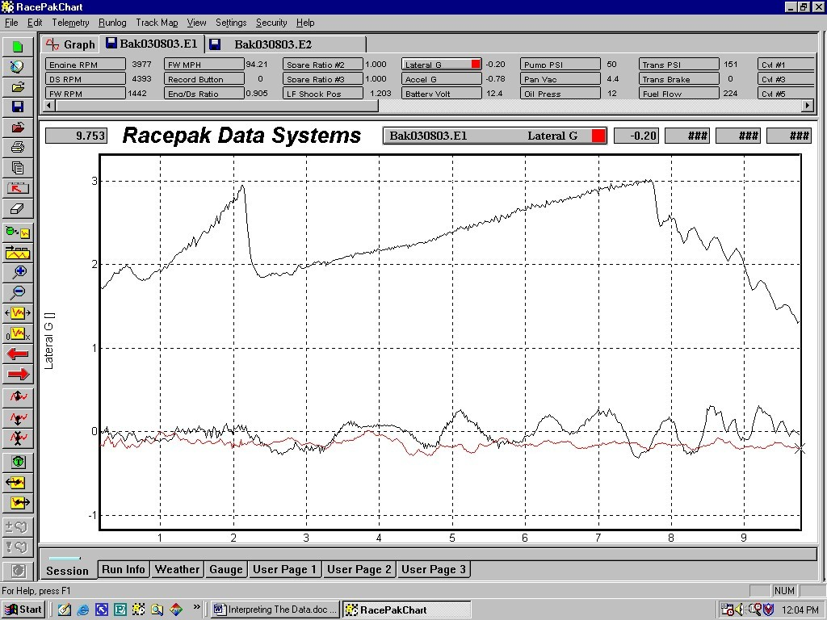
This is a great screen image that was used to show a driver why he lost a race. It also points out one of the values of monitoring lateral G-force. This car lost ET unexpectedly from the first to second round of eliminations. Afterwards the runs were overlaid to create this comparison. The red graph line is the lateral G-force of the first round. The black lines are the lateral G-force of the second round and the engine RPM. All of the channels of data were almost identical with the exception of the lateral G-force. Follow the black lateral G-force line and you will see how the driver got himself into trouble when he shifted the car. He steered the car out of the groove, and then he spent the rest of track and into the shutdown area making steering corrections. That cost him a couple of thousandths in ET and the race. Lateral G-force told the reason why.

PRESSURES

There are many pressures and vacuums that can be monitored with your Racepak data recorder. The most common are fuel pressure, oil pressure, pan vacuum, nitrous (bottle & fuel), and boost, but the list of possibilities is almost endless. While it is important to know what the pressure or vacuum readings may be, there isn’t a lot that can be said or shown about them. The main reason you want to monitor these items is for the purpose of helping you tune the engine, keeping on eye on them to maintain consistency and reliability, and as an aid to solving any problems that may arise. We are often told that monitoring these items have helped racers spot problems before they became costly damage. While that is gratifying to hear, we see just as many racers who monitor a lot of information, but then fail to make use of it. In the following screen view we will show you two examples of pressure channels and how both had a message for the owner of this car.

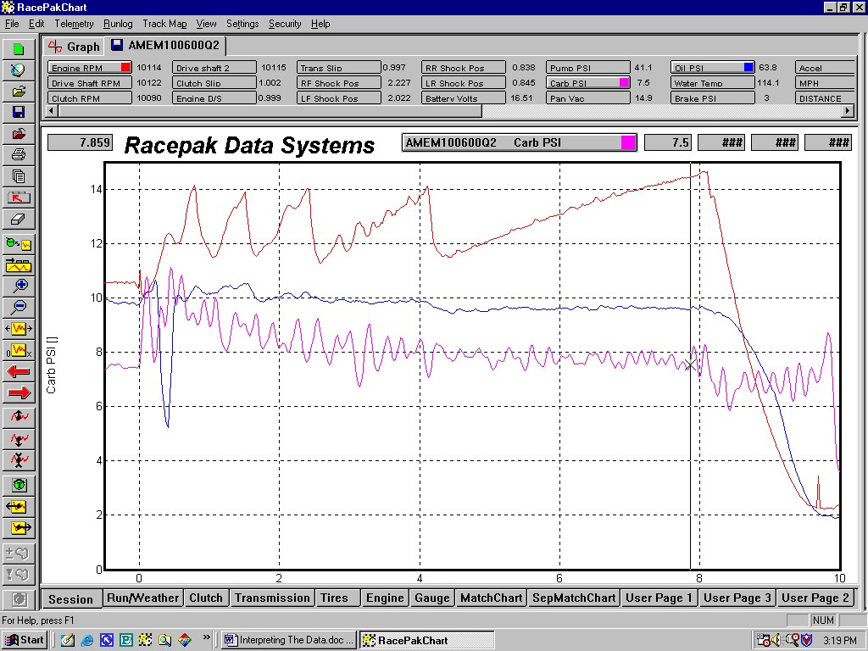
The racer with this carbureted door car loaded up his data recorder with a lot of sensors then failed to look at the data they were collecting. That almost bit him. Check out the blue Oil Pressure graph line on the screen above. Even though this car was also equipped with an oil pressure gauge, the driver never saw the loss in pressure that was occurring as the car left the starting line. It wasn’t until a third party was looking at the graphs one day that the drop in pressure was noted. The car had made a lot of runs by this time, and it was only sheer luck that prevented them from damaging an engine

The purple Carburetor Fuel Pressure graph might look scary with all of it’s up and down movement, but that is somewhat common. Remember that the floats open and close the needles and seats, which in turn raises and lowers the fuel pressure in the line. What might be worth paying attention to here is that as the car leaves the starting line it has a lot of fuel pressure (10-11 psi), but this gets progressively lower throughout the run. At the end of the run the fuel system is down to 7-8 psi. Although this is sufficient to run this car, it might be an indicator that the fuel supply is not keeping up with the demand of the engine? Are the float levels getting lower the longer the engine is at WOT? Could more fuel volume be of help here?

SHOCK TRAVEL

Monitoring the movement of the suspension is similar to monitoring clutch slip. Both are vital to the success of the car, and without data any adjustments are just a shot in the dark. That is why you will find shock travel sensors on all four corners of every Pro Stock car. These sensors provide a record of how the car is reacting during the launch, and on through the gear changes down the track. Knowing what the suspension is doing is a component of the puzzle in figuring out what the tires and clutch are also doing. Watching the car, or videotaping the run, can only provide a clue as to what is actually happening under the car. If you are working with adjustable shocks, or consulting with shock engineers, knowing the compression and rebound travel, and the rate of travel, are essential pieces of shock information. Shock travel sensors provide that information. In addition they can monitor how evenly your chassis is transferring power to both rear tires.

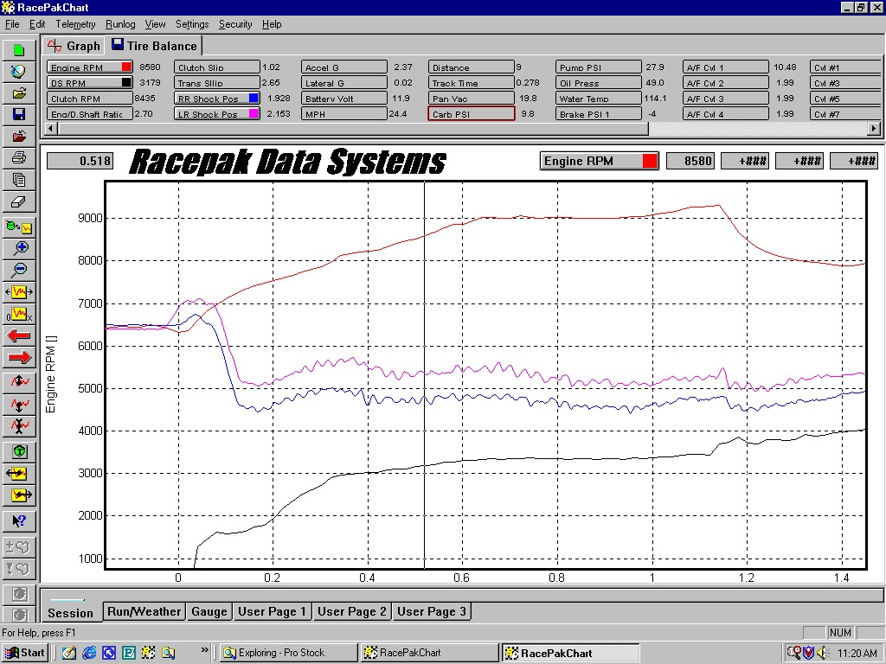
Here we have illuminated the graphs from the two rear shock travel sensors (purple and blue), along with the engine and drive shaft RPM. We have zoomed in to show only the first 1.4 seconds of the run, or just past the 1-2 shift. Notice how the shock travel sensors are both at the same height when the car is staged, and then extend (due to tire squat) as power is initially applied to the rear end. This is quickly followed by unequal amounts of compression as the car launches. This is the result of the torque planting the right rear corner harder. Of additional interest here are the oscillations in both shock travel sensors. With this graph the racer discovered that he had a problem, and upon inspection found that both rear tires were out of balance. It isn’t unusual for shock travel sensors to alert users that they were unknowingly bottoming out the travel in their shocks, or as in this case expose problems such as driveline balance and rims or tires that were out of round.

OVERVIEW

There is an amazing amount of information to be uncovered about your racecar through the use of data acquisition. Your data recorder is a tool, and the more time you take to learn how to use it properly, the better it will serve you. The following are some general suggestions you will want keep in mind in regards to getting the most out of your data recorder.

Do not wait until you are at the racetrack to test and use your data recorder for the first time. There is enough to do at the track without adding this to your list of things to do.

If you spot something on a graph that looks unusual it is helpful to place the cursor at that point on the screen, and then, individually, illuminate the other graph lines. By looking at what is happening on the other channels of data at the same point in time, or just slightly before, you can often spot the reason for the odd occurrence.

Read and use the Quick Start manual that came with your system. It is full of guides that will not only help you learn how to use your recorder, but also how to customize the screen view to your preferences. Read it a second time after you have spent some time using your recorder.

Learn what each of the icons on the toolbar can do. They can make the time you spend looking at the data, and how you use your recorder, much more worthwhile and enjoyable.

Make use of the Quick Graphs feature. With Quick Graph you can illuminate your favorite selection of channels on your screen with just three quick clicks of your mouse.

Averaging is another great feature of the DataLink Windows software. It gives you some great analytical information about the data you have collected. It can be a very enlightening tool to use when you have some spare time. How to use Averaging is also explained in the Quick Start manual.

Get in the habit of filling out the log pages at the bottom of the screen. You will be surprised how valuable this information will become to you when looking at your run files after a period of time has passed.

If you are viewing your data using a laptop computer, equip it with a mouse. Navigating around the screen is much quicker and more precise with a mouse than with a laptop’s finger pad or track ball.

Your data recorder monitors events that are happening in your racecar at a rate much quicker than a human being is capable of observing those same events. It also remembers these things in greater detail. A human sometimes doesn’t see everything that goes on, or sees only what he wants to see, and even worse, forgets much of what he saw. For that reason it is good to use your data recorder as an unbiased witness to what really occurred during a run. Use it to verify what happened, and even what didn’t happen.

We hope you have found this look at the basics of racecar data recording to be helpful. Our hope is that it has provided you with a good starting point from which to hone your own skills of ‘interpreting the data’. Your success, through the use of our data acquisition systems, is how we measure our success.

Racepak Data Systems

“20 YEARS OF DATA”
1985-2005

